Conclusion:

What is the correlation (R2 value) between sales and income?

The correlation between sales and income is positive strong relation and correlation which is 0.78.

it means that when the income increases the sales also will be impacted and increase also.

What is the correlation (R2 value) between customer ratings and product return rate?

The Correlation between customer ratings and product return rate is 0.69 which’s a slightly good negative relationship.

It means when the ROI of the product increase, the customer rating will decrease.

As per the below

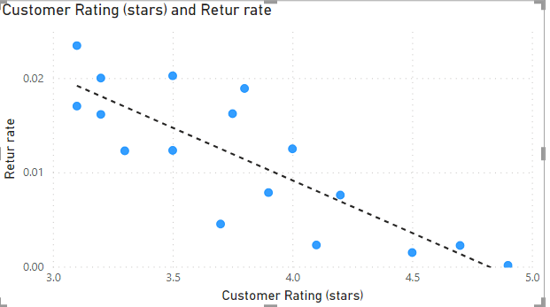

What are the linear regression formulas to predict customer sales and customer incomes?

The formula to predict customer sales and customer incomes is.

Y = 0.01X+ -722.14

Y = will be the prediction of income

X = will be the customer Sales

M =0.01

B = -722.14

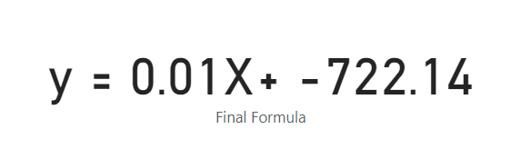

Which customer do you predict has the highest income?

As per the linear regression predicts the highest income will be for

Customer name: Jone Little

Customer ID JLit30836

Predicted income: 556790.49 $

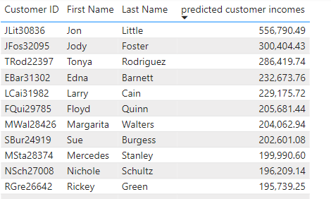

Which product will be advertised the most?

As per the prediction, the ROI has negative correlation with the customer rates.

The product which needs more advertising is Gloves Winter.